Fashion Club  We will bring together a group of people who share the same passions and ambition towards fashion while expanding creativity. | 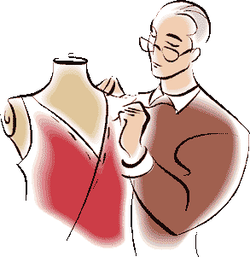 |  | 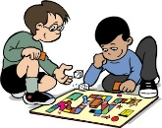  Board Game Club  We will learn about fairness, rules, directions, probability, and luck! We will work together playing board games, exploring modifying directions, and creating our own board games!
Pinterest Club  Your creativity will be challenged! The purpose is to encourage and help each other become craft masters! We will have a lot of fun creating wonderful things! |  |  | Origami Club  We will learn to make lots of different projects, balloons, animals, valentines, and some modular origami (using lots of little pieces to make a larger project). |  | 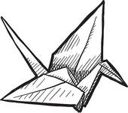
Shark Tank  Have you dreamt of something that could change the world? In Shark Tank you will have the opportunity to create a product/invention that solves a problem at the school. | 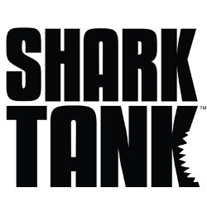 |  | Kids & Zumba Club  Zumba is fitness for everybody and every body! Join us to learn the key of keeping healthy while balancing between fun, effectiveness and familiarity. | 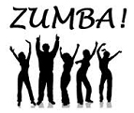
Foot Work  We will explore various ways to use our bodies as instruments of expression, genres such as jazz, modern, hip hop, African, lyrical and more. To conclude your experience, we will prepare dance pieces that represent the dance genres learned and present it in a Fine Arts showcase. | 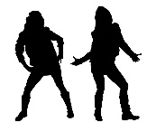 |  | Stomp the Yard (Step)  We will learn to use our bodies as rhythmic instruments. We will learn to stomp our feet, dance (yes, we may ‘whip), and move to create a show that will be showcased to K-5. |  | 
Sewing Club  We will learn how to hand sew using a needle and thread. Each week we will execute a sewing project! |  | 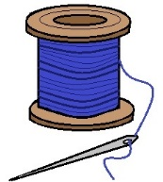 | History Club  We will make the past come to alive! We will learn how exciting events in the past still affect us today. |  |  | 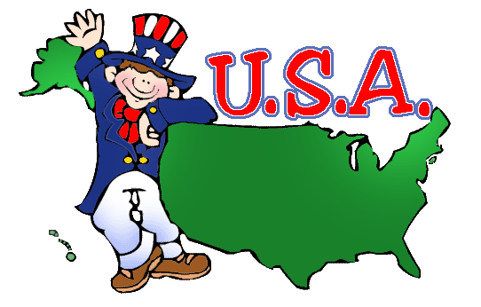
Billy Kimani (?) |  |  | Theater Club

